Spiritual , Moral , Social and Cultural Definitions

Spiritual
Explore beliefs and experience; respect faiths, feelings and values; enjoy learning about oneself, others and the surrounding world; use imagination and creativity; reflect.
Moral
Recognise right and wrong; respect the law; understand consequences; investigate moral and ethical issues; offer reasoned views.
Social
Use a range of social skills; participate in the local community; appreciate diverse viewpoints; participate, volunteer and cooperate; resolve conflict; engage with the 'British values' of democracy, the rule of law, liberty, respect and tolerance.
Cultural
Appreciate cultural influences; appreciate the role of Britain's parliamentary system; participate in culture opportunities; understand, accept, respect and celebrate diversity
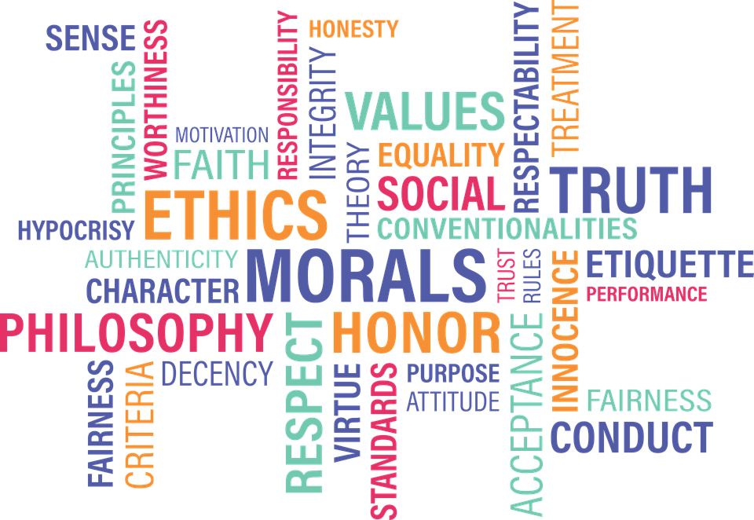
We have a SMSC policy in place at In-Tuition that goes in to more detail about how we, as a school adopt the principles required to deliver SMSC development within our curriculum planning and teaching.

